🧾 Common Types of Network Cables:
# Source: Chatgpt (GPT‑5 Mini) at [12/18/2025]
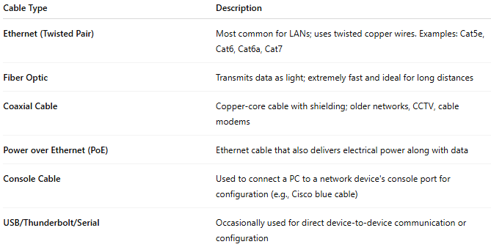

Cable Type | Description
Ethernet (Twisted Pair) | Most common for LANs; uses twisted copper wires. Examples: Cat5e, Cat6, Cat6a, Cat7
Fiber Optic | Transmits data as light; extremely fast and ideal for long distances
Coaxial Cable | Copper-core cable with shielding; older networks, CCTV, cable modems
Power over Ethernet (PoE) | Ethernet cable that also delivers electrical power along with data
Console Cable | Used to connect a PC to a network device's console port for configuration (e.g., Cisco blue cable)
USB/Thunderbolt/Serial | Occasionally used for direct device-to-device communication or configuration

